WORLD DRAUGHTS FEDERATION (FMJD)

COMMITTEE OF THE PROBLEMISM INTERNATIONAL (CPI FMJD)

CPI-INFO

THE OFFICIAL ISSUE OF THE CPI FMJD

N 3, August, 2004

CONTENTS
2….. Final result of the PWC in total
4….. Final result of the PWC in A-Category
5….. Final result of the PWC in B-Category
5….. The result of the International solver-contest of the PWC problems
6….. Final result of the PWC in C-Category
6….. Winners-tables of contests “Lietuva-2001” and “FFJD-2002”
7..… Final result of the PWC in D-Category
7….. Winners-tables of the PWC
8...... Final result of the PWC in E-Category and in F-Category
9...... Best problems of the PWC in every category
10… Rating-table to 1 of July 2004
11… New International titles
12… International contest in memory of S.de Bruijn
………………………………………………………………………….
The CPI members:
Yushkevitch, S., President,
Mironositska, 75, kv 14, 61002 , Kharkov, Ukraine, E-mail : yushkevitch@yahoo.com

Bus, J., Secretary,

Holland, E-mail : jaapbus@t-online.de

Kaciuska, A., Member,

Architektu 38-21 5407, Siauliai, Lithuania,

Tel: +370-11462306, E-mail : kaciuska@splius.lt

Tavernier, A., Member,
33 Rue de Montmorency, 78990, Elancourt, France
Tel: +33-134829 195, E-mail : tavernieralain@wanadoo.fr

Final result of the First Personal World Championship of the Problemism (PWC) 2002-2004
in type of combinational problems
according to the points sum of four best scores of every participant
Place taken | Participant name, country | Points sum | Scores in every category
Place taken | Participant name, country | Points sum | A | B | C | D | E | F
1 | B.Fedorov  (Ukraine) | 596 | 62  (A36) | 149  (B34) | 153  (C35) | 126  (D26) | 164  (E16) | 130  (F21)
2 | A.Rom  (USA) | 579 | 130  (A24) | 146  (B24) | 139  (C23) | 164  (D18) | 130  (E13) | -  (F17)
3 | B.Morkus  (Lithuania) | 577 | 0  (A20) | 30  (B20) | 123  (C19) | 127  (D16) | 148  (E11) | 179  (F14)
4 | S.Perepelkin  (Russsia) | 574 | 130  (A19) | 145  (B19) | 104  (C18) | 162  (D15) | 77  (E10) | 137  (F13)
5 | D.Nikolaev  (Russsia) | 549 | 114  (A15) | 116  (B16) | 138  (C15) | 102  (D13) | 132  (E9) | 163  (F12)
6 | V.Matus  (Russsia) | 500 | 113  (A23) | 121  (B23) | 153  (C22) | 0  (D17) | 95  (E12) | 113  (F16)
7 | T.Smedinga  (Holland) | 499 | 10  (A35) | 0  (B33) | 143  (C34) | 120  (D25) | 115  (E15) | 121  (F20)
8 | A.de Jong  (Holland) | 444 | 65  (A13) | 0  (B14) | 129  (C13) | 132  (D12) | 0  (E8) | 118  (F11)
9 | D.de Ruiter  (Holland) | 393 | 42  (A8) | 90  (B9) | 75  (C8) | 0  (D7) | 140  (E5) | 88  (F7)
10 | A.Uvarov  (Ukraine) | 375 | 103  (A7) | 110  (B8) | 27  (C7) | 107  (D6) | 0  (E4) | 55  (F6)
11 | V.Masiulis  (Lithuania) | 374 | 94  (A12) | 50  (B13) | 0  (C12) | 127  (D11) |  | 103  (F10)
12 | J.Bus  (Holland) | 362 | 100  (A11) | 80  (B12) | 20  (C11) | 119  (D10) | -  (E7) | 63  (F9)
13 | V.Muliar  (Ukraine) | 359 | 50  (A38) | 127  (B36) | 90  (C37) | 92  (D28)
14 | A.Kaciuska  (Lithuania) | 339 | 108  (A21) | 69  (B21) | 82  (C20) |  |  | 80  (F15)
15 | A.Sapegin  (Belarus) | 328 | 91  (A44) | 126  (B41) | 0  (C42) | 111  (D33) | 0  (E21) | 0  (F27)
16 | A.Maslov  (Ukraine) | 318 | 86  (A26) | 120  (B26) | 0  (C25) | 0  (D19) |  | 112  (F18)
17 | JC.Patry  (France) | 306 | 105  (A1) | 70  (B1) | 35  (C1) | 0  (D1) | 96  (E1) | 30  (F1)
18 | M.Fedorov  (Ukraine) | 268 | 124  (A32) | 119  (B31) | 0  (C31) | 25  (D23) | 0  (E14) | 0  (F19)
19 | N.Shapoval  (Ukraine) | 266 | 0  (A40) | 134  (B38) | 0  (C39) | 0  (D30) | 91  (E18) | 41  (F24)
20 | S.Ustianov  (Ukraine) | 246 | 139  (A29) | 107  (B28) | -  (C28) | 0  (D21)
21 | I.Ivatsko  (Ukraine) | 207 | 62  (A43) | 30  (B40) | 0  (C41) | 0  (D32) | 90  (E20) | 25  (F26)
22 | E.Kopilov  (Russsia) | 206 | 45  (A46) | 96  (B43) | 0  (C44) | 65  (D34)
23 | A.Vermeulen  (France) | 205 | 77  (A31) | 0  (B30) | 103  (C30) | 25  (D22)
24 | M.Levandovski  (Ukraine) | 193 | 113  (A17) | 0  (B17) | 80  (C16)
25 | V.Shulga  (Belarus) | 146 | 91  (A22) | 25  (B22) | 30  (C21)
26 | V.Zhuravlev  (Russsia) | 137 | 0  (A30) | 67  (B29) | 70  (C29)
27 | L.Vitoshkin  (Belarus) | 131 | 41  (A37) | 35  (B35) | 45  (C36) | 0  (D27) |  | 10  (F22)
28 | L.Condemi  (Italia) | 117 | 89  (A18) | 0  (B18) | 13  (C17) | 15  (D14)
29 | V.Kocharov  (Russsia) | 116 | 0  (A33) | 10  (B32) | 106  (C32)
30 | F.Voland  (France) | 115 | 42  (A14) | 73  (B15) | 0  (C14)
31 | S.Rézel  (France) | 109 | 15  (A25) | 94  (B25) | 0  (C24)
32 | E.Skliar  (Israel) | 102 |  | 0  (B3) | 102  (C2) | 0  (D2) |  | 0  (F2)
33 | S.Klomp  (Holland) | 101 | 101  (A9) | 0  (B10) | 0  (C9) | 0  (D8) | 0  (E6) | -  (F8)
34 | V.Tsvetkov  (Russsia) | 76 | 0  (A34) |  | 76  (C33) | 0  (D24)
35 | A.Jovaisas  (Lithuania) | 45 | 20  (A6) | 0  (B7) | 0  (C6) |  |  | 25  (F5)
36 | J.Siozinys  (Lithuania) | 37 | 37  (A10) | 0  (B11) | 0  (C10) | 0  (D9)
37 | P.Garlopeau  (France) | 35 | 12  (A4) | 0  (B5) | 0  (C4) | 0  (D4) | 13  (E2) | 10  (F3)
38 | B.Ivanov  (Belarus) | 30 | 0  (A45) | 30  (B42) | 0  (C43) |  |  | 0  (F28)
39 | S.M van Eijk  (Holland) | 22 | 0  (A2) | 22  (B2)
40 | V.Malashenko  (Belarus) | 20 | 0  (A42) | 0  (B39) | 20  (C40) | 0  (D31) | 0  (E19) | 0  (F25)
41 | A.Liakhovskij  (Belarus) | 15 | 5  (A39) | -  (B37) | 0  (C38) | 0  (D29) | 0  (E17) | 10  (F23)
42 | R.Mackevicius  (Lithuania) | 10 | 0  (A28) | 0  (B27) | 10  (C27)
43-46 | B.Cataldi  (Italia) | - | 0  (A3) | 0  (B4) | 0  (C3) | 0  (D3)
43-46 | R.Outters  (France) | - | 0  (A16)
43-46 | U.Rikmanis  (Lettonia) | - | 0  (A27) |  | 0  (C26) | 0  (D20)
43-46 | A.Terekhov  (Russsia) | - | 0  (A41)

Nota bene: M.Sabater (author of A5,B6,C5,D5,E3,F4) has declared he does not want his name would be mentioned in PWC participants list because he does think his problem F4 was eliminated unjustice. The CPI FMJD has satisfied M.Sabater declaration. His name is mentioned no where in PWC participants lists.
S.Yushkevitch ,
The CPI FMJD President

Final result of the PWC 2002-2004 in type of combinational problems in A-category
Place taken | Number of the position, participant name, country |  | Final score | Judge’s scores
Place taken |  |  | Final score | ED | AT | SY | SZ
1 | 29 | S.Ustianov (Ukr) | 139 | 57 | 40 | 85 | 82
2 | 19 | S.Perepelkin (Rus) | 130 | 56 | 50 | 79 | 74
2 | 24 | A.Rom (USA) | 130 | 49 | 60 | 72 | 70
4 | 32 | M.Fedorov (Ukr) | 124 | 54 | 70 | 51 | 71
5 | 15 | D.Nikolaev (Rus) | 114 | 59 | 45 | 55 | 73
6 | 17 | M.Levandovski (Ukr) | 113 | 58 | 45 | 62 | 55
6 | 23 | V.Matus (Rus) | 113 | 64 | 10 | 49 | 71
8 | 21 | A.Kaciuska (Lit) | 108 | 53 | 55 | 50 | 72
9 | 1 | JC.Patry (Fr) | 105 | 55 | 50 | 58 | 37
10 | 7 | A.Uvarov (Ukr) | 103 | 70 | 50 | 53 | 5
11 | 9 | S.Klomp (Holl) | 101 | 44 | 15 | 70 | 57
12 | 11 | J.Bus (Holl) | 100 | 54 | 50 | 50 | 50
13 | 12 | V.Masiulis (Lit) | 94 | 41 | 10 | 54 | 53
14 | 22 | V.Shulga (Bel) | 91 | 41 | 50 | 40 | 63
14 | 44 | A.Sapegin (Bel) | 91 | 39 | 35 | 52 | 64
16 | 18 | L.Condemi (It) | 89 | 44 | 25 | 45 | 47
17 | 26 | A.Maslov (Ukr) | 86 | 30 | 30 | 68 | 56
18 | 31 | A.Vermeulen (Fr) | 77 | 52 | 15 | 49 | 28
19 | 13 | A.de Jong (Holl) | 65 | 60 | 0 | 65 | 5
20 | 36 | B.Fedorov (Ukr) | 62 | 26 | 30 | 74 | 32
20 | 43 | I.Ivatsko (Ukr) | 62 | 20 | 20 | 50 | 42
22 | 38 | V.Muliar (Ukr) | 50 | 56 | 0 | 48 | 2
23 | 46 | E.Kopilov (Rus) | 45 | 40 | 0 | 35 | 10
24 | 8 | D.de Ruiter (Holl) | 42 | 68 | 0 | 42 | 0
24 | 14 | F.Voland (Fr) | 42 | 53 | 0 | 30 | 12
26 | 37 | L.Vitoshkin (Bel) | 41 | 49 | 15 | 25 | 16
27 | 10 | J.Siozinys (Lit) | 37 | 27 | 0 | 48 | 10
28 | 6 | A.Jovaisas (Lit) | 20 | 55 | 0 | 0 | 20
29 | 25 | S.Rézel (Fr) | 15 | 15 | 0 | 20 | 0
30 | 4 | P.Garlopeau (Fr) | 12 | 56 | 0 | 10 | 2
31 | 35 | T.Smedinga (Holl) | 10 | 37 | 0 | 10 | 0
32 | 39 | A.Liakhovskij (Bel) | 5 | 24 | 0 | 5 | 0
 | 2 | S.M van Eijk (Holl) | 0 | 0 | 0 | 0 | 0
 | 3 | B.Cataldi (It) | 0 | 0 | 0 | 0 | 0
 | 16 | R.Outters (Fr) | 0 | 0 | 0 | 0 | 0
 | 20 | B.Morkus (Lit) | 0 | 0 | 0 | 0 | 0
 | 27 | U.Rikmanis (Lat) | 0 | 0 | 0 | 0 | 0
 | 28 | R.Mackevicius (Lit) | 0 | 0 | 0 | 0 | 0
 | 30 | V.Zhuravlev (Rus) | 0 | 0 | 0 | 0 | 0
 | 33 | V.Kocharov (Rus) | 0 | 0 | 0 | 0 | 0
 | 34 | V.Tsvetkov (Rus) | 0 | 0 | 0 | 0 | 0
 | 40 | N.Shapoval (Ukr) | 0 | 0 | 0 | 0 | 0
 | 41 | A.Terekhov (Rus) | 0 | 0 | 0 | 0 | 0
 | 42 | V.Malashenko (Bel) | 0 | 0 | 0 | 0 | 0
 | 45 | B.Ivanov (Bel) | 0 | 0 | 0 | 0 | 0
The abbreviation of judge’s scores is:
ED: Eric van Dusseldorp (Holland);
AT: Alain Tavernier (France);
SY: Serge Yushkevitch (Ukraine);
SZ: Stassis Zilevicius (Lithuania).

Final result of the PWC 2002-2004 in type of combinational problems in B-category
Place taken | Number of the position, participant name, country |  | Final score | Judge’s scores
Place taken |  |  | Final score | ED | AT | SY | SZ
1 | 34 | B.Fedorov (Ukr) | 149 | 77 | 50 | 89 | 72
2 | 24 | A.Rom (USA) | 146 | 74 | 60 | 80 | 72
3 | 19 | S.Perepelkin (Rus) | 145 | 80 | 65 | 56 | 82
4 | 38 | N.Shapoval (Ukr) | 134 | 64 | 70 | 64 | 71
5 | 36 | V.Muliar (Ukr) | 127 | 76 | 70 | 49 | 57
6 | 41 | A.Sapegin (Bel) | 126 | 65 | 35 | 62 | 64
7 | 23 | V.Matus (Rus) | 121 | 65 | 55 | 68 | 56
8 | 26 | A.Maslov (Ukr) | 120 | 62 | 50 | 59 | 61
9 | 31 | M.Fedorov (Ukr) | 119 | 54 | 70 | 45 | 65
10 | 16 | D.Nikolaev (Rus) | 116 | 55 | 55 | 65 | 61
11 | 8 | A.Uvarov (Ukr) | 110 | 55 | 55 | 55 | 41
12 | 28 | S.Ustianov (Ukr) | 107 | 52 | 35 | 63 | 55
13 | 43 | E.Kopilov (Rus) | 96 | 54 | 60 | 35 | 42
14 | 25 | S.Rézel (Fr) | 94 | 44 | 40 | 50 | 69
15 | 9 | D.de Ruiter (Holl) | 90 | 53 | 50 | 40 | 0
16 | 12 | J.Bus (Holl) | 80 | 77 | 0 | 58 | 22
17 | 15 | F.Voland (Fr) | 73 | 45 | 25 | 61 | 28
18 | 1 | JC.Patry (Fr) | 70 | 55 | 50 | 20 | 0
19 | 21 | A.Kaciuska (Lit) | 69 | 44 | 10 | 42 | 27
20 | 29 | V.Zhuravlev (Rus) | 67 | 34 | 30 | 40 | 33
21 | 13 | V.Masiulis (Lit) | 50 | 20 | 30 | 33 | 0
22 | 35 | L.Vitoshkin (Bel) | 35 | 33 | 0 | 15 | 20
23 | 20 | B.Morkus (Lit) | 30 | 62 | 0 | 10 | 20
23 | 40 | I.Ivatsko (Ukr) | 30 | 34 | 0 | 10 | 20
23 | 42 | B.Ivanov (Bel) | 30 | 53 | 0 | 30 | 0
26 | 22 | V.Shulga (Bel) | 25 | 53 | 0 | 25 | 0
27 | 2 | S.M van Eijk (Holl) | 22 | 56 | 0 | 22 | 0
28 | 32 | V.Kocharov (Rus) | 10 | 43 | 0 | 10 | 0
 | 3 | E.Skliar (Isr) | 0 | 0 | 0 | 0 | 0
 | 4 | B.Cataldi (It) | 0 | 0 | 0 | 0 | 0
 | 5 | P.Garlopeau (Fr) | 0 | 0 | 0 | 0 | 0
 | 7 | A.Jovaisas (Lit) | 0 | 0 | 0 | 0 | 0
 | 10 | S.Klomp (Holl) | 0 | 0 | 0 | 0 | 0
 | 11 | J.Siozinys (Lit) | 0 | 0 | 0 | 0 | 0
 | 14 | A.de Jong (Holl) | 0 | 0 | 0 | 0 | 0
 | 17 | M.Levandovski (Ukr) | 0 | 0 | 0 | 0 | 0
 | 18 | L.Condemi (It) | 0 | 0 | 0 | 0 | 0
 | 27 | R.Mackevicius (Lit) | 0 | 0 | 0 | 0 | 0
 | 30 | A.Vermeulen (Fr) | 0 | 0 | 0 | 0 | 0
 | 33 | T.Smedinga (Holl) | 0 | 0 | 0 | 0 | 0
 | 39 | V.Malashenko (Bel) | 0 | 0 | 0 | 0 | 0
 | 37 | A.Liakhovskij (Bel) | - | - | - | - | -

FINAL RESULT OF THE INTERNATIONAL SOLVER- CONTEST OF PWC PROBLEMS
(organized by E.van Dusseldorp at E.van Dusseldorp web-site)
1/2. M. Lepsic (Kroatia), 48 points, 75 euro
1/2. G. Magelinskas (Lithuania), 48 points, 75 euro
3. S. Mezenin (Ukraine), 47 points, 25 euro
4. J. Uijterlinde (Netherlands), 36 points, 5. A. Hilchenko (Russia), 34 points, 6. W. Ludwig (Holland), 30 points
7. Koeljbanov (Belarussia), 25 points. 8. I. Ivatsko (Ukraine), 24 points, 9. A. Spijkstra (Holland), 23 points
10. V. Zhuravlev (Russia), 10 points. Special prize: A.Hlasny (Poland) for the most anticipations: 50 euro

Final result of the PWC 2002-2004 in type of combinational problems in C-category
Place taken | Number of the position, participant name, country |  | Final score | Judge’s scores
Place taken |  |  | Final score | ED | AT | SY | SZ
1 | 22 | V.Matus (Rus) | 153 | 68 | 75 | 78 | 81
1 | 35 | B.Fedorov (Ukr) | 153 | 78 | 75 | 68 | 81
3 | 34 | T.Smedinga (Holl) | 143 | 80 | 65 | 71 | 72
4 | 23 | A.Rom (USA) | 139 | 55 | 65 | 74 | 81
5 | 15 | D.Nikolaev (Rus) | 138 | 68 | 70 | 65 | 86
6 | 13 | A.de Jong (Holl) | 129 | 85 | 65 | 64 | 57
7 | 19 | B.Morkus (Lit) | 123 | 53 | 45 | 70 | 71
8 | 32 | V.Kocharov (Rus) | 106 | 39 | 55 | 59 | 51
9 | 18 | S.Perepelkin (Rus) | 104 | 54 | 50 | 49 | 80
10 | 30 | A.Vermeulen (Fr) | 103 | 63 | 40 | 67 | 30
11 | 2 | E.Skliar (Isr) | 102 | 62 | 30 | 47 | 55
12 | 37 | V.Muliar (Ukr) | 90 | 34 | 40 | 50 | 62
13 | 20 | A.Kaciuska (Lit) | 82 | 52 | 20 | 47 | 35
14 | 16 | M.Levandovski (Ukr) | 80 | 25 | 40 | 58 | 40
15 | 33 | V.Tsvetkov (Rus) | 76 | 26 | 10 | 52 | 50
16 | 8 | D.de Ruiter (Holl) | 75 | 34 | 40 | 35 | 61
17 | 29 | V.Zhuravlev (Rus) | 70 | 19 | 30 | 45 | 40
18 | 36 | L.Vitoshkin (Bel) | 45 | 45 | 0 | 53 | 0
19 | 1 | JC.Patry (Fr) | 35 | 76 | 0 | 15 | 20
20 | 21 | V.Shulga (Bel) | 30 | 51 | 15 | 15 | 5
21 | 7 | A.Uvarov (Ukr) | 27 | 66 | 0 | 25 | 2
22 | 11 | J.Bus (Holl) | 20 | 50 | 0 | 20 | 0
22 | 40 | V.Malashenko (Bel) | 20 | 79 | 0 | 20 | 0
24 | 17 | L.Condemi (It) | 13 | 10 | 0 | 32 | 3
25 | 27 | R.Mackevicius (Lit) | 10 | 52 | 0 | 10 | 0
 | 3 | B.Cataldi (It) | 0 | 0 | 0 | 0 | 0
 | 4 | P.Garlopeau (Fr) | 0 | 0 | 0 | 0 | 0
 | 6 | A.Jovaisas (Lit) | 0 | 0 | 0 | 0 | 0
 | 9 | S.Klomp (Holl) | 0 | 0 | 0 | 0 | 0
 | 10 | J.Siozinys (Lit) | 0 | 0 | 0 | 0 | 0
 | 12 | V.Masiulis (Lit) | 0 | 0 | 0 | 0 | 0
 | 14 | F.Voland (Fr) | 0 | 0 | 0 | 0 | 0
 | 24 | S.Rézel (Fr) | 0 | 0 | 0 | 0 | 0
 | 25 | A.Maslov (Ukr) | 0 | 0 | 0 | 0 | 0
 | 26 | U.Rikmanis (Lat) | 0 | 0 | 0 | 0 | 0
 | 31 | M.Fedorov (Ukr) | 0 | 0 | 0 | 0 | 0
 | 38 | A.Liakhovskij (Bel) | 0 | 0 | 0 | 0 | 0
 | 39 | N.Shapoval (Ukr) | 0 | 0 | 0 | 0 | 0
 | 41 | I.Ivatsko (Ukr) | 0 | 0 | 0 | 0 | 0
 | 42 | A.Sapegin (Bel) | 0 | 0 | 0 | 0 | 0
 | 43 | B.Ivanov (Bel) | 0 | 0 | 0 | 0 | 0
 | 44 | E.Kopilov (Rus) | 0 | 0 | 0 | 0 | 0
 | 28 | S.Ustianov (Ukr) | - | - | - | - | -

WINNERS TABLE OF THE CONTEST “LIETUVA-2001” (for master-points)
A | 1/2.A.Nikolajev | 1/2.D.Nikolajev | 3/4.D.Nikolajev | 3/4.M.Levandovsky | 5.A.Terekhov | 6/7.V.Bieliauskas  J.Gobins
B | 1. B.Morkus | 2. A.Tavernier | 3. G.Dumas | 4. A.Tavernier | 5. A.Jovaišas | 6. J.Bus

WINNERS TABLE OF THE CONTEST “FFJD-2002” (for master-points)
A | 1. B.Morkus | 2. D.Nikolaev | 3. A.Rom | 4. D.de Ruiter | 5. G.Dumas | 6. E.Kopilov
B | 1. B.Fedorov | 2. A.Rom | 3. B.Fedorov | 4 V.Shulga | 5. J.Siozinys | 6.A.Vermeulen

Final result of the PWC 2002-2004 in type of combinational problems in D-category
Place taken | Number of the position, participant name, country |  | Final score | Judge’s scores
Place taken |  |  | Final score | ED | AT | SY | SZ
1 | 18 | A.Rom (USA) | 164 | 85 | 50 | 79 | 86
2 | 15 | S.Perepelkin (Rus) | 162 | 90 | 75 | 75 | 87
3 | 12 | A.de Jong (Holl) | 132 | 59 | 70 | 62 | 74
4 | 11 | V.Masiulis (Lit) | 127 | 46 | 60 | 67 | 70
4 | 16 | B.Morkus (Lit) | 127 | 62 | 60 | 65 | 96
6 | 26 | B.Fedorov (Ukr) | 126 | 56 | 50 | 70 | 84
7 | 25 | T.Smedinga (Holl) | 120 | 55 | 65 | 55 | 78
8 | 10 | J.Bus (Holl) | 119 | 61 | 45 | 58 | 68
9 | 33 | A.Sapegin (Bel) | 111 | 54 | 50 | 57 | 62
10 | 6 | A.Uvarov (Ukr) | 107 | 57 | 50 | 60 | 40
11 | 13 | D.Nikolaev (Rus) | 102 | 60 | 40 | 64 | 42
12 | 28 | V.Muliar (Ukr) | 92 | 39 | 35 | 53 | 65
13 | 34 | E.Kopilov (Rus) | 65 | 11 | 35 | 45 | 30
14 | 22 | A.Vermeulen (Fr) | 25 | 41 | 0 | 10 | 15
14 | 23 | M.Fedorov (Ukr) | 25 | 0 | 0 | 25 | 83
16 | 14 | L.Condemi (It) | 15 | 22 | 0 | 15 | 0
 | 1 | JC.Patry (Fr) | 0 | 0 | 0 | 0 | 0
 | 2 | E.Skliar (Isr) | 0 | 0 | 0 | 0 | 0
 | 3 | B.Cataldi (It) | 0 | 0 | 0 | 0 | 0
 | 4 | P.Garlopeau (Fr) | 0 | 0 | 0 | 0 | 0
 | 7 | D.de Ruiter (Holl) | 0 | 0 | 0 | 0 | 0
 | 8 | S.Klomp (Holl) | 0 | 0 | 0 | 0 | 0
 | 9 | J.Siozinys (Lit) | 0 | 0 | 0 | 0 | 0
 | 17 | V.Matus (Rus) | 0 | 0 | 0 | 0 | 0
 | 19 | A.Maslov (Ukr) | 0 | 0 | 0 | 0 | 0
 | 20 | U.Rikmanis (Lat) | 0 | 0 | 0 | 0 | 0
 | 21 | S.Ustianov (Ukr) | 0 | 0 | 0 | 0 | 0
 | 24 | V.Tsvetkov (Rus) | 0 | 0 | 0 | 0 | 0
 | 27 | L.Vitoshkin (Bel) | 0 | 0 | 0 | 0 | 0
 | 29 | A.Liakhovskij (Bel) | 0 | 0 | 0 | 0 | 0
 | 30 | N.Shapoval (Ukr) | 0 | 0 | 0 | 0 | 0
 | 31 | V.Malashenko (Bel) | 0 | 0 | 0 | 0 | 0
 | 32 | I.Ivatsko (Ukr) | 0 | 0 | 0 | 0 | 0

WINNERS TABLE OF PWC (for master-points)

Cat.
A | 1. S.Ustianov | 2/3. S.Perepelkin | 2/3. A.Rom | 4. M.Fedorov | 5. D.Nikolaev | 6/7.V.Matus,  M.Levandovski
B | 1. B.Fedorov | 2. A.Rom | 3. S.Perepelkin | 4. N.Shapoval | 5. V.Muliar | 6. A.Sapegin
C | 1. B.Fedorov | 1/2. V.Matus | 3. T.Smedinga | 4. A.Rom | 5. D.Nikolaev | 6. A.de Jong
D | 1. A.Rom | 2. S.Perepelkin | 3. A.de Jong | 4/5.V.Masiulis | 4/5. B.Morkus | 6. B.Fedorov
E | 1. B.Fedorov | 2. B.Morkus | 3. D.de Ruiter | 4. D.Nikolaev | 5. A.Rom | 6. T.Smedinga
F | 1. B.Morkus | 2. D.Nikolaev | 3. S.Perepelkin | 4. B.Fedorov | 5. T.Smedinga | 6. A.de Jong

(Remark: since 12.10.2002 master points are accounted for first 6 places if at least two International grandmasters participated in a contest in such way: 1 place-30 points, 2-25, 3-20, 4-15, 5-10, 6-5 points).

Final result of the PWC 2002-2004 in type of combinational problems in E-category
Place taken | Number of the position, participant name, country |  | Final score | Judge’s scores
Place taken |  |  | Final score | ED | AT | SY | SZ
1 | 16 | B.Fedorov (Ukr) | 164 | 58 | 85 | 79 | 87
2 | 11 | B.Morkus (Lit) | 148 | 56 | 65 | 84 | 83
3 | 5 | D.de Ruiter (Holl) | 140 | 73 | 70 | 70 | 63
4 | 9 | D.Nikolaev (Rus) | 132 | 33 | 65 | 74 | 67
5 | 13 | A.Rom (USA) | 130 | 64 | 55 | 69 | 66
6 | 15 | T.Smedinga (Holl) | 115 | 45 | 65 | 50 | 71
7 | 1 | JC.Patry (Fr) | 96 | 25 | 40 | 56 | 56
8 | 12 | V.Matus (Rus) | 95 | 33 | 0 | 62 | 64
9 | 18 | N.Shapoval (Ukr) | 91 | 24 | 40 | 73 | 51
10 | 20 | I.Ivatsko (Ukr) | 90 | 12 | 50 | 40 | 63
11 | 10 | S.Perepelkin (Rus) | 77 | 36 | 45 | 30 | 41
12 | 2 | P.Garlopeau (Fr) | 13 | 13 | 0 | 15 | 0
 | 4 | A.Ouvarov (Ukr) | 0 | 0 | 0 | 0 | 0
 | 6 | S.Klomp (Holl) | 0 | 0 | 0 | 0 | 0
 | 8 | A.de Jong (Holl) | 0 | 0 | 0 | 0 | 0
 | 14 | M.Fedorov (Ukr) | 0 | 0 | 0 | 0 | 0
 | 17 | A.Liakovski (Bel) | 0 | 0 | 0 | 0 | 0
 | 19 | V.Malashenko (Bel) | 0 | 0 | 0 | 0 | 0
 | 21 | A.Sapegin (Bel) | 0 | 0 | 0 | 0 | 0
 | 7 | J.Bus (Holl) | - | - | - | - | -

Final result of the PWC 2002-2004 in type of combinational problems in F-category
Place taken | Number of the position, participant name, country |  | Final score | Judge’s scores
Place taken |  |  | Final score | ED | AT | SY | SZ
1 | 14 | B.Morkus (Lit) | 179 | 89 | 60 | 90 | 98
2 | 12 | D.Nikolaev (Rus) | 163 | 86 | 90 | 60 | 77
3 | 13 | S.Perepelkin (Rus) | 137 | 79 | 60 | 63 | 74
4 | 21 | B.Fedorov (Ukr) | 130 | 58 | 55 | 87 | 72
5 | 20 | T.Smedinga (Holl) | 121 | 61 | 60 | 40 | 67
6 | 11 | A.de Jong (Holl) | 118 | 74 | 20 | 70 | 48
7 | 16 | V.Matus (Rus) | 113 | 80 | 40 | 52 | 61
8 | 18 | A.Maslov (Ukr) | 112 | 56 | 45 | 59 | 56
9 | 10 | V.Masiulis (Lit) | 103 | 44 | 70 | 50 | 53
10 | 7 | D.de Ruiter (Holl) | 88 | 43 | 40 | 45 | 69
11 | 15 | A.Kaciuska (Lit) | 80 | 52 | 20 | 55 | 28
12 | 9 | J.Bus (Holl) | 63 | 45 | 10 | 62 | 18
13 | 6 | A.Uvarov (Ukr) | 55 | 71 | 0 | 20 | 35
14 | 24 | N.Shapoval (Ukr) | 41 | 49 | 0 | 15 | 26
15 | 1 | JC.Patry (Fr) | 30 | 44 | 0 | 30 | 0
16 | 5 | A.Jovaisas (Lit) | 25 | 68 | 0 | 20 | 5
16 | 26 | I.Ivatsko (Ukr) | 25 | 51 | 0 | 25 | 0
18 | 3 | P.Garlopeau (Fr) | 10 | 36 | 0 | 10 | 0
18 | 22 | L.Vitoshkin (Bel) | 10 | 45 | 0 | 10 | 0
18 | 23 | A.Liakhovskij (Bel) | 10 | 34 | 0 | 10 | 0
 | 2 | E.Skliar (Isr) | 0 | 0 | 0 | 0 | 0
 | 19 | M.Fedorov (Ukr) | 0 | 0 | 0 | 5 | 0
 | 25 | V.Malashenko (Bel) | 0 | 0 | 0 | 0 | 0
 | 27 | A.Sapegin (Bel) | 0 | 0 | 0 | 0 | 0
 | 28 | B.Ivanov (Rus) | 0 | 0 | 0 | 0 | 0
 | 8 | S.Klomp (Holl) | - | - | - | - | -
 | 17 | A.Rom (USA) | - | - | - | - | -

Best problems of the PWC in every category

Category A
S.Ustianov (Ukr), A29  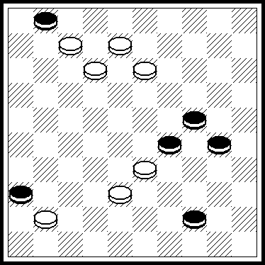 | S.Perepelkin (Rus), A19  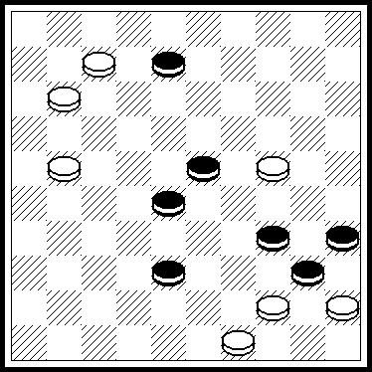 | A.Rom (USA), A24  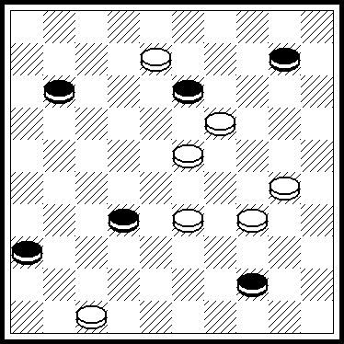

Category B
B.Fedorov (Ukr), B34  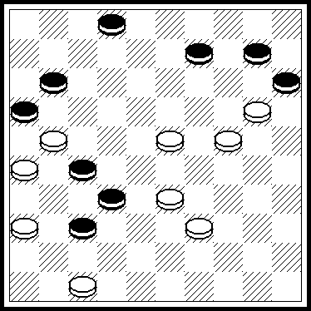 | A.Rom (USA), B24  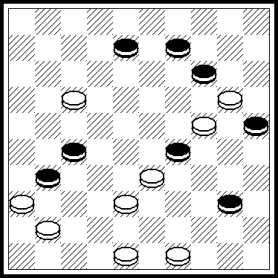 | S.Perepelkin (Rus), B19  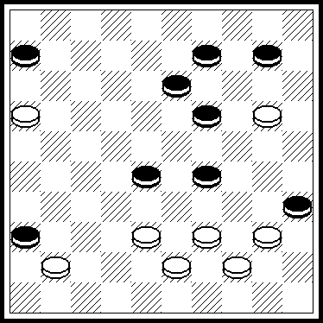
Category C
V.Matus (Rus), C22  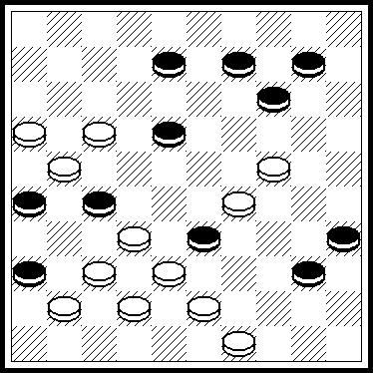 | B.Fedorov (Ukr), C35  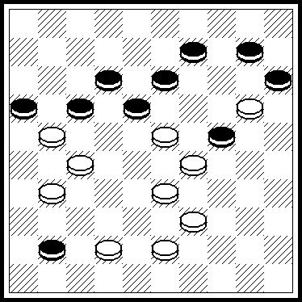 | T.Smedinga (Holl), C34  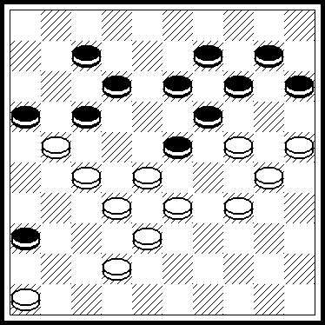
Category D
A.Rom (USA), D18  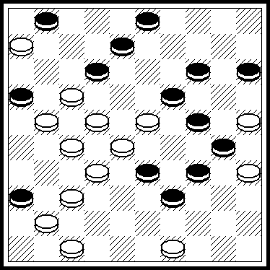 | S.Perepelkin (Rus), D15  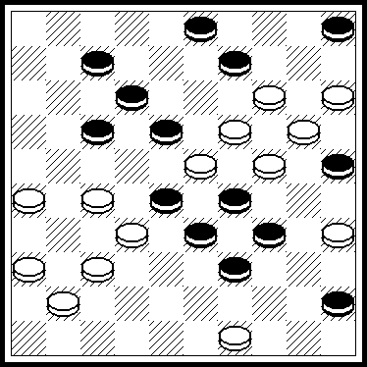 | A.de Jong (Holl), D12  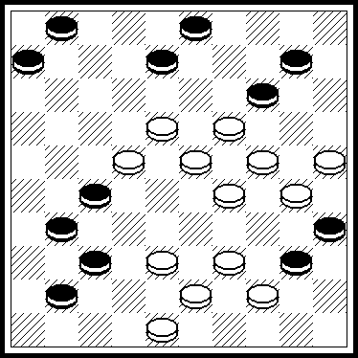
Category E
B.Fedorov (Ukr), E16  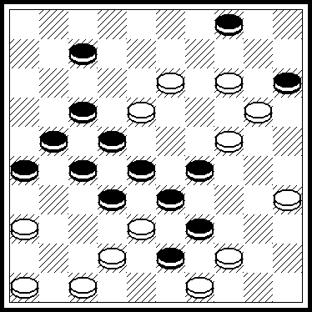 | B.Morkus (Lit), E11  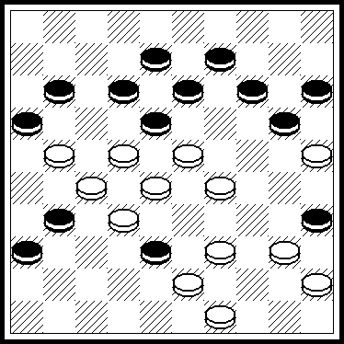 | D.de Ruiter (Holl), E5  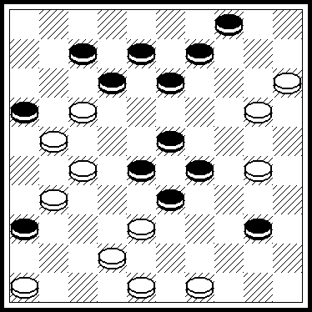
Category F
B.Morkus (Lit), F14  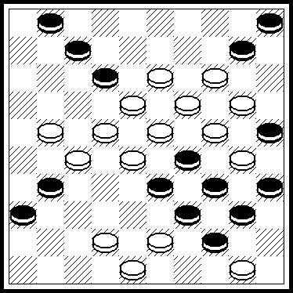 | D.Nikolaev (Rus), F12  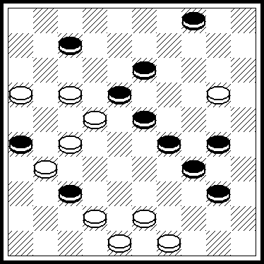 | S.Perepelkin (Rus), F13  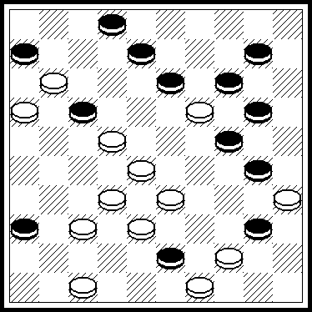

A29: 28,23,3(33A)50(336B)2(29)127,2-11(17)6(34)1(40)45 + A) (29)50(47)33,2,11(30C) 39(35)34(6)7(11,40) 11(45) 50 +B) (47)33,2,11. Variante A + C) (29)39(7)6(34)1(40)45 + A19: 19,43(389A)2,17,44,34 + A) (409)23, 2, 33(20,39)38(44)33(49a)44,34 + a) (50)6(40,45)1 +A24: 41,2,40,45,5(40)28(45)50 + B34: 42,31(48x30x28) 312, 4,7,21 + A) (48,25,28)312,4(20a)415,7,21 + B24: 44,12,3,43,19,16,27,5 + B19: 15,4,394,3,33(49A)33-17,17,7 + A) (11)6(49)26(27/21)26-17 + C22: 31z,171(42A)43,7,11,2,45,15,29(20,40)33(45)50 + A) (47)7,43. C35: 14, 20, 5,26,46(20)32(24)38(30) 43(35) 49(21,40)11(45)50 + C34: 282,41,339,18,4,20,4x42x25,2(40) 11(45) 50 + D18: 238,18,9,2,44,30,7,38,1(20)10,14 + D15: 43, 261, 31,30,8,3,48,1,40,14,4 + D12: 34,39,240,9,42,20, 189,4,2 + E16: 461,417,30,31,36,44,31,38,2,139,3,14 + E11: 33,40,19, 3,29,19,2,20,49,450,19 + E5: 41,44,11, 2,14, 24, 42,9, 15,304,19 + F14: 37,37,509,2,7,3,249,26(43A)14(12B)8,32 + A) (12) 8, 14,32 + B) (19)21,32 + F12: 39,39,14,9,44,171,2,18,40 + F13: 29,4(24)38,41,23,3,8,27,27 +

RATING-TABLE (TO 1 OF JULY 2004)
 | Names | Countries | Points | Places taken
 |  |  |  | 1 | 2 | 3 | 4 | 5 | 6
1 | Zubov Evgraf | Russia | 555 | 13 | 4 | 3 | 4
2 | Perepelkin Serguei | Russia | 550 | 8 | 3 | 11 | 5 | 3
3 | Yushkevitch Serge | Ukraine | 470 | 8 | 6 | 3 | 4 | 5
4 | Matus Vladimir | Russia | 420 | 6 | 8 | 2 | 4 | 1 | 1
5 | Nikolaev Alexander | Russia | 365 | 7 | 5 | 1 | 3 | 1
6 | Kuyken Andréas | Suisse | 315 | 4 | 5 | 3 | 2 | 6
7 | Tavernier Alain | France | 315 | 1 | 5 | 7 | 3 | 8
8 | Bastiaannet Johan | Holland | 310 | 5 | 4 | 3 | 3 | 1
9 | Morkus Benjaminas | Lithuania | 300 | 5 | 4 | 3 | 1 | 1
10 | Fedorov Boris | Ukraine | 200 | 4 | 1 | 1 | 3 | 1
11 | De Ruiter Dirk | Holland | 180 | 2 | 2 | 2 | 2 | 4
12 | Miedema Aart + |  | 155 | 1 | 2 | 3 | 3 | 2
13 | Torrès Jean Paul | France | 150 | 1 | 2 | 2 | 4 | 2
14 | Rom Alexander | U.S.A. | 150 | 1 | 3 | 1 | 1 | 1
15 | Nikolaev Dimitri | Russia | 140 | 1 | 2 | 1 | 1 | 2
16 | Fedoruk Alexander | Russia | 110 | 2 |  | 2 | 1 | 2
17 | De Jong Ardjan | Holland | 110 | 2 | 1 | 1 |  |  | 2
18 | Fourgous René + |  | 90 | 1 | 1 | 2 | 1
19 | Konkov Alexander | Russie | 90 |  | 2 | 1 | 2 | 3
20 | Klomp Steven | Holland | 85 |  | 2 | 2 | 1 | 1
21 | Ustianov Stanislas | Ukraine | 75 | 2 |  | 1
22 | Andrejews Gennadij | Lettonia | 65 | 1 | 1 |  | 1 | 1
23 | Bakumets Alexandre + |  | 60 |  | 1 | 2 | 1
24 | Muliar Vassil | Ukraine | 60 | 1 |  |  | 2 | 1
25 | Shulga Victor | Belarus | 55 |  |  | 2 | 2
26 | Studentsov Viktor | Lithuania | 55 |  | 2 | 1
27 | van de Linde Gerrit + |  | 50 | 1 | 1
28 | Silo Grigorijus | Lithuania | 45 |  | 2 |  |  | 1
29 | Levandovsky Mikhajio | Ukraine | 45 |  |  | 2 |  | 1 | 1
30 | Fedorov Mikhail | Ukraine | 45 | 1 |  |  | 1
31 | Dumas Gérard | France | 40 |  |  | 1 | 1 | 2
32 | Sabonis Victor | Lithuania | 40 |  | 2
33 | Vitoskin Leonid | Belarus | 40 | 1 |  |  | 1
34 | Smedinga Tijpke | Holland | 40 |  |  | 1 |  | 2 | 1
35 | Sabater Michel | France | 35 |  | 1 |  | 1 | 1
36 | Zilevicius Stasys | Lithuania | 35 |  | 1 |  | 1 | 1
37 | Bugajev Igor | Ukraine | 30 | 1
38 | Hlasny Adam | Poland | 30 | 1
39 | Kaciuska Algimantas | Lithuania | 30 |  |  | 1 | 1 | 1
40 | Pankratjev Alexei | Russie | 30 | 1
41 | Trofimenko Vjatcheslav | Ukraine | 30 |  |  | 1 | 1 | 1
42 | Uvarov Anatolij | Ukraine | 30 | 1
43 | Ivatsko Ivan | Ukraine | 25 |  | 1 |  |  | 1
44 | Klomp Jan | Holland | 25 |  |  | 1 |  | 2
45 | Vermeulen Alain | France | 25 |  |  | 1 |  | 1 | 1
46 | Gorin Alexandre | Russia | 20 |  | 1
47 | Kravtsov Grigorij | Belarus | 20 |  |  | 1 |  | 1
48 | Maslov Alexander | Ukraine | 20 |  |  |  | 1 | 2
49 | Morkus Tadikas | Lithuania | 20 |  | 1
50 | Patry Jean Claude | France | 20 |  | 1
51 | Romon Christian | France | 20 |  |  |  | 2
52 | Beemer Arnoldus + |  | 15 |  |  | 1
53 | Bulat Vadim | Belarus | 15 |  |  | 1
54 | De Kooter Ruud | Holland | 15 |  |  | 1
55 | Kovalev Serguei | Russia | 15 |  |  | 1
56 | Leysis Juozas | Lithuania | 15 |  |  | 1
57 | Masiulis Virmantas | Lithuania | 15 |  |  |  | 1
58 | Shapoval Nikolai | Ukraine | 15 |  |  |  | 1
59 | Tsomik Nakham | Lithuania | 15 |  |  |  | 1 | 1
60 | van der Stoep Arie | Holland | 15 |  |  | 1
61 | van Sterkenburg Franck | Holland | 15 |  |  | 1
62 | Faber Léo | Holland | 10 |  |  |  |  | 2
63 | Flyanzraich Pavel | Russia | 10 |  |  |  | 1
64 | Malashkevitch Krichtof | Belarus | 10 |  |  |  | 1
65 | Simons Hubert | Holland | 10 |  |  |  | 1
66 | Siozinys Jonas | Lithuania | 10 |  |  |  |  | 1
67 | Telpuk Vasiliy | Belarus | 10 |  |  |  | 1
68 | Terechov Anatoliy | Russia | 10 |  |  |  |  | 1
69 | van Rooij Martinus | Holland | 10 |  |  |  | 1
70 | Voland Francis | France | 10 |  |  |  | 1
71 | Bieliauskas Valdas | Lithuania | 5 |  |  |  |  |  | 1
72 | Bobrov Guennadiy | Russie | 5 |  |  |  |  | 1
73 | Tsvetov Mikhail | Israel | 5 |  |  |  |  | 1
74 | Gobins Janis | Lettonia | 5 |  |  |  |  |  | 1
75 | Ivanov Boris | Belarus | 5 |  |  |  |  | 1
76 | Bus Jaap | Holland | 5 |  |  |  |  |  | 1
77 | Jovaisas Alvydas | Lithuania | 5 |  |  |  |  | 1
78 | Khaletskij Konstantine | Uzbekistan | 5 |  |  |  |  | 1
79 | Kopilov Evgenij | Russia | 5 |  |  |  |  |  | 1
80 | Malashenko Vladimir | Belarus | 5 |  |  |  |  | 1
81 | Melinon Antoine + |  | 5 |  |  |  |  | 1
82 | Rickmanis Uldis | Lettonia | 5 |  |  |  |  | 1
83 | Sapegin Alexandre | Belarus | 5 |  |  |  |  |  | 1
84 | van Alphen Hendrik Johan + |  | 5 |  |  |  |  | 1
85 | van den Berg Dirk + |  | 5 |  |  |  |  | 1
86 | Veldstra Meno | Holland | 5 |  |  |  |  | 1

NEW INTERNATIONAL TITLES FOR PROBLEMISTS

12.10.2002 the Section-100 Assembly and 23/24.08.2004 the General Assembly of the FMJD awarded titles:
Grand Master International Problemism: to A.Tavernier (France) and B.Morkus (Lithuania).
Grand Master International Honoris Causa: to B.Shkitkin (Russia).
Master International Problemism: to A.Fedoruk (Russia).
Master FMJD Problemism: to G.Andreews (Lettonia), V.Studentsov (Lithuania), A.-J. de Long (Holland), S.Klomp (Holland), A.Konkov (Russia), V.Muliar (Ukraine), B.Fedorov (Ukraine), D.Nikolaev (Russia).
At the CD 10.01.04 the FMJD diplomes was awarded to N.Pustynnikov (Russia) for his exceptional contribution in the problemism development in former USSR and with his 90-th birthday anniversary.
At the GA FMJD 23/24.08.2004 the title MEMBRE HONNEUR was awarded to S.de Bruijn (Holland) who was both the SPI President and SPI/CPI Secretary for long time for his contribution for the problemism development within of the FMJD.
With great regret the CPI informs that Steef de Bruijn is died 01.05.2004. In memory of S.de Bruijn the CPI organizes International contest (see page 12).
S.Yushkevitch,
The CPI FMJD President.

INTERNATIONAL CONTEST IN MEMORY OF STEEF DE BRUIJN (1932-2004)

("MEMORIAL STEEF DE BRUIJN")

This contest is organized by the CPI FMJD in memory of S.de Bruijn who died 1 of May 2004 in 72 ages. S.de Bruijn was the SPI FMJD President since 1989 till 1996 and the Secretary of the SPI/CPI FMJD since 1996 till 2003. Too S.de Bruijn was one of principal ideologists of International Rules of problemism. This contest is named in honour of S.de Bruijn memory for his exceptional services for the problemism development both at National and International levels.

The contest is organized in the type of Combinational problems (C-problems). The contest is run according to the International Rules (RI) of problemism for C-problems on the 100-squares board, without a King in the initial position and with the task : "White to move and win". C-problems corresponding to either MASTER LEVEL or SUPERIOR LEVEL are permitted. All problems sent must be unpublished. Published problems and problems (or their correction) that took part in earlier competition are not permitted. Problems with join authorship also are not permitted.

The contest consists of only one category. The number of pieces is: minimum 10x10, maximum 12x12. A theme of problems is free.

Obligatory conditions for the initial position are as follow:
- White pieces staying on squares 6,7,8,9,10 are not allowed.
- There is not allowed the presence of a white piece, which may go to the King line without an opposition of black (for instance: white piece staying on the square 16 without a black piece staying either on 1, or 6, or 7, or 11, or 17, anD, from other side, white piece staying on the square 15 without a black piece staying either on 4, or 5, or 6, or 10, or 14 etc.).

Thematic variant(s) only should be indicated in the solution of the problem. Problems, which will not correspond to regulations of this contest, will not be scored.

Every participant may send 1 or 2 problems with the indication of complete solution, his name, pre-name and his address. Problems should be sent by post. Problems sent by e-mail are not accepted.

The deadline to send is: 1 of December 2004. Problems should be sent to the address:

Mr J. BULSTRA,
B. van Galenstraat 28,
8101 ES RAALTE,
HOLLAND.

In accordance with the CPI Statutes, Master points will be awarded to winners of this contest. Participants who will win 1, 2 and 3 places will be awarded by money prizes with 60, 30 and 30 euro accordingly. If they will want, they may obtain instead of money prize the subscription of DE PROBLEMIST for two years (first place) and for one year (second and third places).

All information for this contest (regulations, problems, remarks, preliminary and final results etc.) will be placed in Internet at websites:
http://www.fmjd.nl
http://www.euronet.nl/users/evdussel
http://www.gambler.ru/plus/tavlei/index.html

